Parallel extraction of summary information across multi-element arrays
Jan Balaguer1, Andrei Gorea2, Elizabeth Michael1, Christopher Summerfield1
1Department of Experimental Psychology, University of Oxford, Oxford OX1 3UD, UK
2CNRS UMR 8158, Laboratoire Psychologie de la Perception, 75006 Paris, France

Observers are capable of making rapid and accurate judgments of the summary information in an array composed of multiple elements. Whilst some theories have argued that this suggests that the visual system is capable of automatic extraction of statistical information from a visual scene, others have suggested that serial strategies may play a role. To test whether perceptual averaging occurs in parallel or in series, we asked observers to judge the average feature (shape or colour) in a centrally-presented visual array with a variable number of elements (‘squircles’, i.e. shapes that varied continuously from shape to circle). As reported previously, we found that the variance (heterogeneity) of the array slowed responding and increased error rates, but set size (2, 4 or 8 items) had no influence on performance. Reasoning that it might be possible to average in parallel across information on a single dimension (e.g. shape or colour) but not a conjunction of two dimensions, we devised a new averaging task in which the decision value was continuously signalled by the conjunction of two dimensions, with more red/square or blue/circle items belonging to one category and more blue/square or red/circle items belonging to the other. Surprisingly, for these stimuli we found no influence of the array variability and an inverse set-size effect, with better performance for larger arrays. This latter finding cannot be due to increased precision for larger set sizes (or less variable arrays) because in both experiments elements were pseudosampled to ensure a fixed mean value. Together, these findings suggest that averaging of both one- and two-dimensional information can be conducted in parallel, supporting models suggesting that observers automatically extract summary information from visual scenes.

Description

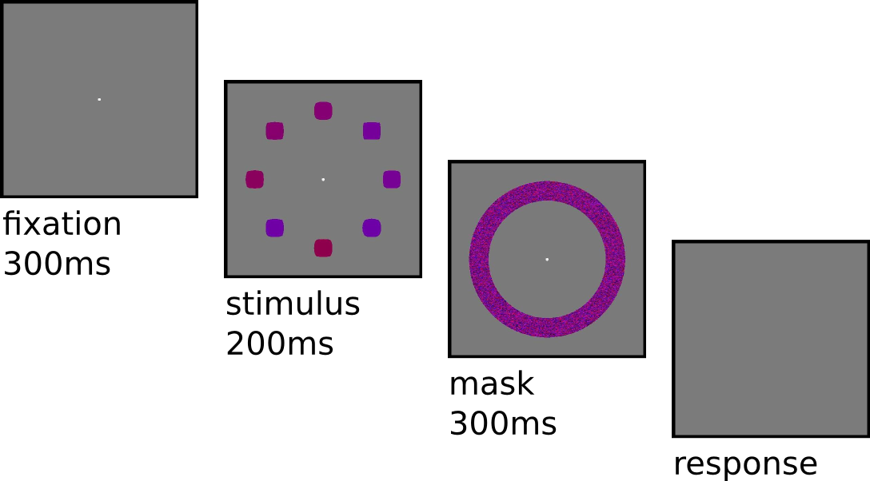

Figure 1. Task design
Subjects were asked to discriminate and categorize the average value of SHAPE (task 1), or both SHAPE and COLOR (task 2) of a set of elements ('squircles').
Three different set-sizes (2,4,8), two different variances (0.1 and 0.2) and 9 different means (uniformly distributed between -0.25 and +0.25) were used to generate those sets.
Sample distributions were generated under constraints, forcing both mean and average to represent the underlying values with an error smaller than .001 (constrained sampling), following a gaussian distribution.

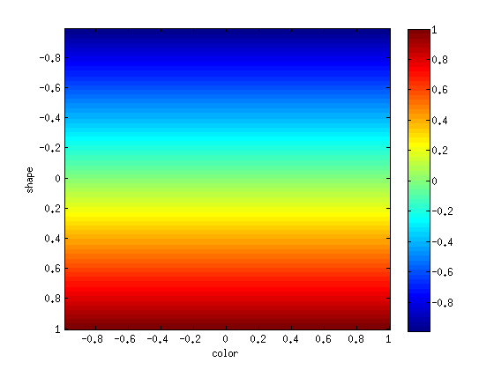

Figure 2a. Value-space for SHAPE (task 1)
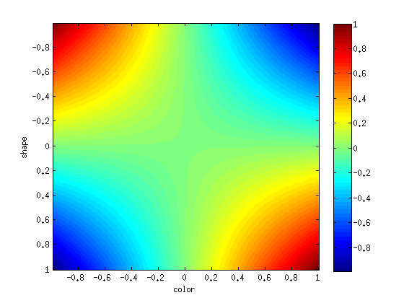

Figure 2b. Value space for both SHAPE and COLOR (task 2)
Value-space in the 2 dimension task.

Figure 2. Different value-spaces for tasks 1 and 2.
Color-dimension is represented (between -1 and +1) in the x-axis.
Shape-dimension is represented (between -1 and +1) in the y-axis.
Each item has an associated value (between -1 and +1), represented in this figure by color (labelled in the right bar – blue to red). Each set is then represented as an array of values.
Categorization was made over the sign of the average value of all elements. So, reddish sets are categorized as Positive, bluish sets are categorized as Negative.
Figure 2a. Value space for SHAPE (task 1)
Color, as shown, was irrelevant for this task. The value of each item maps its shape.
Figure 2b. Value space for both SHAPE and COLOR (task 2)
Both color and shape were relevant for this task. The value of each item is v = color * shape.

Figure 3d. Psychometric curves across means for different variances (task 2 – SHAPE/COL)
Figure 3. Psychometric curves
Psychometric curves in figure 3a,b,c,d show the probability of response the average response between categories +1 and -1 for a given mean (represented in x-axis).
Figures 3a,b show results for task 1.
Figures 3c,d show results for task 2.
Figures 3a,c show differences effects across set-size conditions.
Figures 3b,d show differences effects across variance conditions.

In accordance with ANOVA results (see figure 1):
– there is an effect over variance for task 1.
– there is an effect over set-size for task 2.

Annexe 1 – results

dimensions:
means [mean] (0 .05 ; 0.10 ; 0.15 ; 0.20)
variances [var] (0.10 ; 0.20)
set-sizes [ss] (2 ; 4 ; 8)

Task 1 – 1D Shape
ANOVA Performance
Effect 01: mean F(1.76,26.33)=99.476, p=0.000
Effect 02: var F(1.99,29.79)=8.923, p=0.001
Effect 03: mean/var F(4.12,61.73)=0.974, p=0.430
Effect 04: ss F(1.00,15.00)=0.467, p=0.505
Effect 05: mean/ss F(3.15,47.18)=2.621, p=0.059
Effect 06: var/ss F(1.37,20.54)=0.318, p=0.649
Effect 07: mean/var/ss F(4.29,64.41)=0.643, p=0.644
ANOVA Reaction Times
Effect 01: mean F(2.31,34.58)=1.371, p=0.268
Effect 02: var F(2.00,29.94)=1.327, p=0.280
Effect 03: mean/var F(4.32,64.75)=0.400, p=0.822
Effect 04: ss F(1.00,15.00)=0.314, p=0.584
Effect 05: mean/ss F(2.39,35.84)=0.721, p=0.516
Effect 06: var/ss F(1.62,24.35)=0.220, p=0.758
Effect 07: mean/var/ss F(2.98,44.70)=0.566, p=0.639
Task 2 – 2D Shape + Color
ANOVA Performance
Effect 01: mean F(1.69,15.18)=68.575, p=0.000
Effect 02: var F(1.73,15.56)=0.147, p=0.835
Effect 03: mean/var F(3.70,33.26)=0.803, p=0.523
Effect 04: ss F(1.00,9.00)=7.651, p=0.022
Effect 05: mean/ss F(3.18,28.62)=0.200, p=0.905
Effect 06: var/ss F(1.32,11.92)=0.127, p=0.796
Effect 07: mean/var/ss F(4.70,42.26)=0.786, p=0.559
ANOVA Reaction Times
Effect 01: mean F(1.03,9.30)=0.696, p=0.430
Effect 02: var F(1.02,9.19)=1.353, p=0.275
Effect 03: mean/var F(1.05,9.44)=1.027, p=0.340
Effect 04: ss F(1.00,9.00)=1.317, p=0.281
Effect 05: mean/ss F(1.05,9.42)=0.835, p=0.389
Effect 06: var/ss F(1.01,9.13)=0.804, p=0.395
Effect 07: mean/var/ss F(1.06,9.54)=0.961, p=0.357

